
CONFIDENTIAL CS/NOV 2026/CSC429

UNIVERSITI TEKNOLOGI MARA FINAL EXAMINATION

COURSE
COURSE CODE
EXAMINATION TIME
COMPUTER ORGANIZATION AND ARCHITECTURE

CSC429
NOVEMBER 2026
3 HOURS

INSTRUCTIONS TO CANDIDATES

- This question paper consists of two (2) parts: PART A (10 Questions) PART B (1 Question)

- Answer ALL questions in the Answer Booklet. Start each answer on a new page.

- Do not bring any material into the examination room unless permission is given by the invigilator .
- Please check to make sure that this examination pack consists of: i) the Question Paper
  - an Answer Booklet - provided by the Faculty

- Answer ALL questions in English.

DO NOT TURN THIS PAGE UNTIL YOU ARE TOLD TO DO SO

This examination paper consists of 6 printed pages.

PART A (80 MARKS)
Answer ALL questions in this part.
QUESTION 1 (5 marks)
- Describe ONE (1) major difference between a tightly coupled multiprocessor system and
a loosely coupled multiprocessor system.
- State the THREE (3) types of cluster architecture.
QUESTION 2 (5 marks)
Draw the Von Neumann architecture and give appropriate example for each component.
QUESTION 3 (5 marks)
Henry Edward "Ed" Roberts
(September 13, 1941 -April 1, 2010)
was an American engineer, entrepreneur and
medical doctor who invented the first
commercially successful personal computer in
1975. He is most often known as "the father of
the personal computer". The computer was
available as a kit for $439 or assembled for
$621 and had several additional add-ons such
as a memory board and interface boards. By
August 1975, over 5,000 Altair 8800 personal
computers were sold; starting the personal
computer revolution.
- In which computer generation that a personal computer is introduced?
- Discuss ONE (1) other major discovery that is found in this generation.
- Advances in laptop and hand-held devices are accelerating during this computer
generation. How such technology is feasible as compared to previous computer
generation?
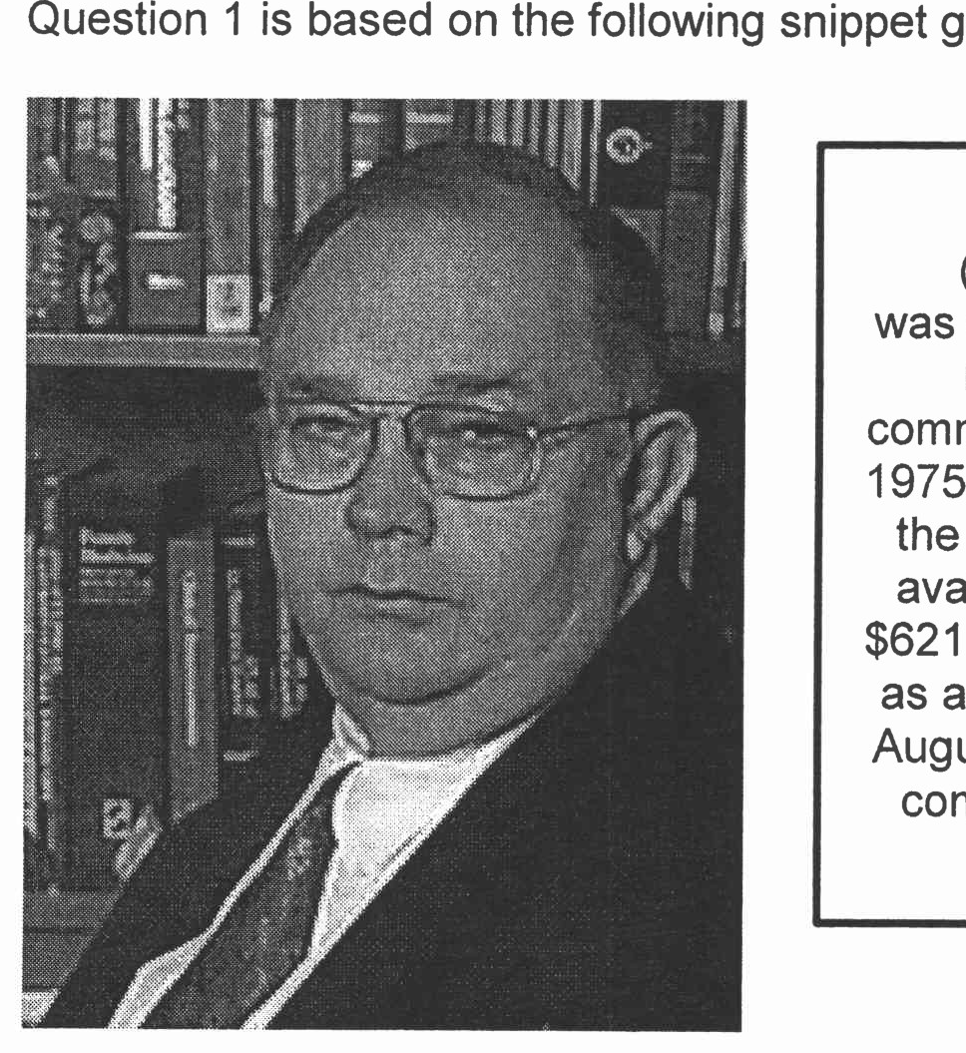
Figure 1: Snippet from a computer science web page.
QUESTION 4 (5 marks)
- Define byte.
- Why base 10 is not suitable for computer number representation?
- In IEEE floating point representation, why exponent is having maximum value of 127
instead of 128?
QUESTION 5 (10 marks)
- Explain the problem in polling 1/0 method.
- Explain how buffering can help to improve the device overall performance?
- Discuss how DMA technique can help the 1/0 transfer performance instead of using polling
method and interrupt 1/0 method?
QUESTION 6 (10 marks)
- Draw Multiple Instruction, Multiple Data Stream (MIMD) with distributed memory
architecture. Use CU as the Control Unit, PU as the Processing Unit, and LM as Local
Memory.
- Draw Multiple Instruction, Multiple Data Stream (MIMD) with shared memory architecture.
Use CU as the Control Unit and PU as the Processing Unit.
- Describe what will happen if the virus attacks the memory in:
- Multiple Instruction, Multiple Data Stream (MIMD) with distributed memory.
- Multiple Instruction, Multiple Data Stream (MIMD) with shared memory.
- Give ONE (1) example of Multiple Instruction, Multiple Data Stream (MIMD) with distributed
memory.
QUESTION 7 (10 marks)
Calculate 9710 + FACEH using the following techniques and show the complete work flow.
- Sign and magnitude.
- I's and 2's complement
QUESTION 8 (10 marks)
Interrupt-driven 1/0 is more efficient compared to the simple programmed 1/0.
- Define interrupt-driven 1/0.
- Describe TWO (2) modes of addressing when the processor, main memory and 1/0
shared a common bus.
- Discuss ONE (1) advantage and ONE (1) disadvantage of the interrupt-driven 1/0.
QUESTION 9 (10 marks)
- Draw Single Instruction, Single data (SISD) architecture with the following information:
- CU is the control unit
- PU is the processing unit
- MU is the memory unit
- IS is the instruction stream
- DS is the data stream
- Describe the parallel architecture.
- Explain ONE (1) benefit of parallel architecture.
- Differentiate between loosely-coupled and strongly-coupled Multiple Instruction, Multiple
Data stream (MIMD) architecture with example.
QUESTION 10 (10 marks)
- Why replacement algorithm for cache is needed?
- Discuss all different types of available replacement.

PART B (20 MARKS)
Answer the question in this part.
QUESTION 11 (20 marks)
Question 1 is based on Figure 2 and Table 1.
Write an appropriate program using correct assembly language notations to compute the
equation shown in Figure 2 using instructions for one-address, two-address, and three-
address. The available instructions are provided in Table 1. The register labeled A, B, C, and
D are fixed, while registers x, y, and z can be used temporarily. The final answer must be
stored in register y.

Figure 2
Table 1 : Machine instruction
One-address | Two-address | Three-address
LOADp | MOV (p,q) | ADD (p.q.r)
STORp | ADD (p,q) | SUB (p,q,r)
ADDp | SUB (p,q) | MUL (p.q.r)
SUBp | MUL (p,q) | DIV(p,q,r)
MULp | DIV(p,q)
DIVp

